# SAP2Invoice Demo

**What it does …**

* It extracts either from a Mailfolder unread emails with Invoices attached or takes the Invoice files from a given Directory location.
* It then sends the Files to UiPath Document understanding Service and extracts the relevant fields with ML. It can be displayed in a validation station.
* After that it calls the SAP Transaction FB60 (hardcoded) and enters the relevant data for the extracted Vendor. If CompanyCode is asked 1710 will be entered (hardcoded, all the mail examples are working with Vendors in 1710)
* All extracted results are written into Excel and a Logfile is also created and animation can be switched on/off

**Requirements** (Language should be English for all apps):

* SAP GUI installed & configured
* After you have installed the SAP GUI Client (see UiPath internal Wiki) you need to enable scripting and check Help Settings of the SAP User you want to run the Demo with.
* [See here](https://docs.uipath.com/studio/v2020.4/docs/sap-configuration-steps#section-enabling-sap-gui-scripting) how to enable scripting (Server *and* Client side)
* [See here](https://docs.uipath.com/studio/v2020.4/docs/sap-configuration-steps#section-enabling-modal-dialog-boxes) how to enable Modal Settings in Help (Serverside user context)
* [See here](https://docs.uipath.com/studio/v2020.4/docs/sap-configuration-steps#section-enabling-high-speed-connections) to check if you have enabled High Speed Connection
* Office (Excel & Outlook) installed (could be also German)
* Recommended: Extra Mailfolder with Demo mails (ready in Demo_documents folder)

***All the rest of the Parameters can be pre-configured in the “default_parameters.xlsx” and many of them can be changed in the first user interaction before the flow starts.***

**Nice to have:**

* If you have an Orchestrator asset for the SAP Login the robot is connected to  
  In the “default_parameters.xlsx” you can define the asset name and folder
* Create an own user in SAP.

The Demo should run in any case with UiPath S4H_FIN. However, as more and more do use this user a splash screen may come up telling you someone else has logged on already and need a choice. The LOGON Workflow covers such exceptions but it’s not a nice message for customers and may distract. Hence you may want to create your own user.

## Creating your own SAP User

1. **Logon to SAP as one of the demo users (works well with S4H_FIN)**

Enter transaction code (TCODE) **SU01**  
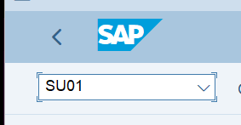

1. **Copy an existing user**

Click on “**Copy**” or use keyboard shortcut “Shift+F5”  
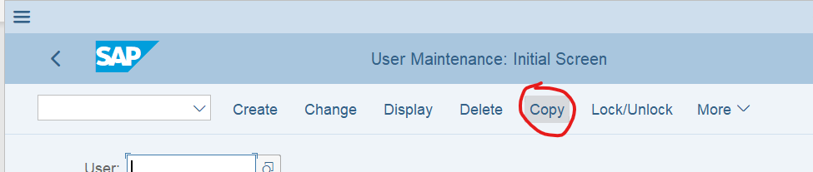

1. **Enter source user-id and new user-id and click on “Copy”**

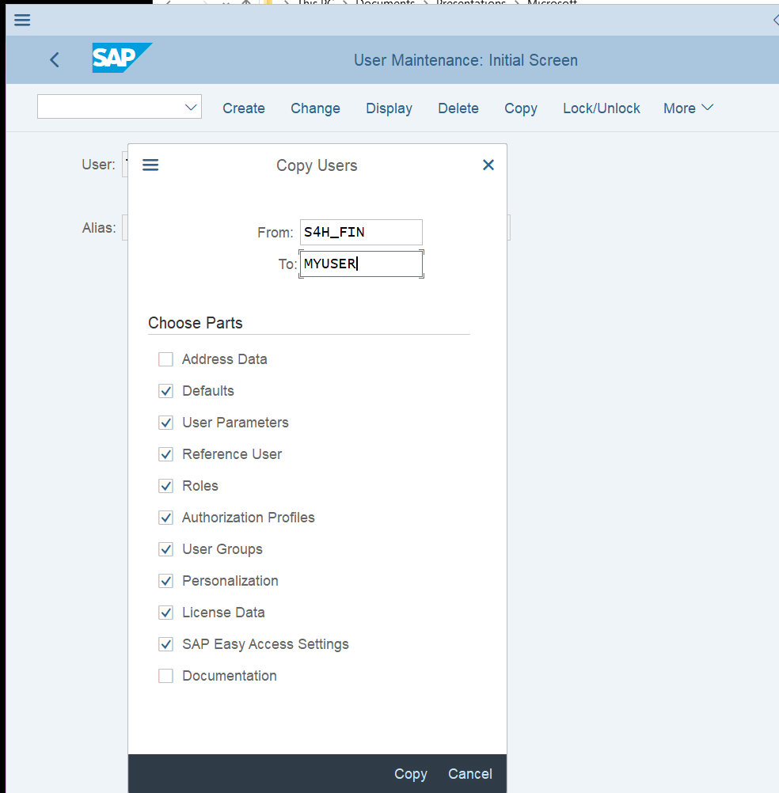

1. **Add default Company (BUK) for transactions**

Select the tab Parameters and add a new line to the parameters table. Parameter ID = BUK, Value of the default Company = 1710 (The SSD Workflow is optimized for that)

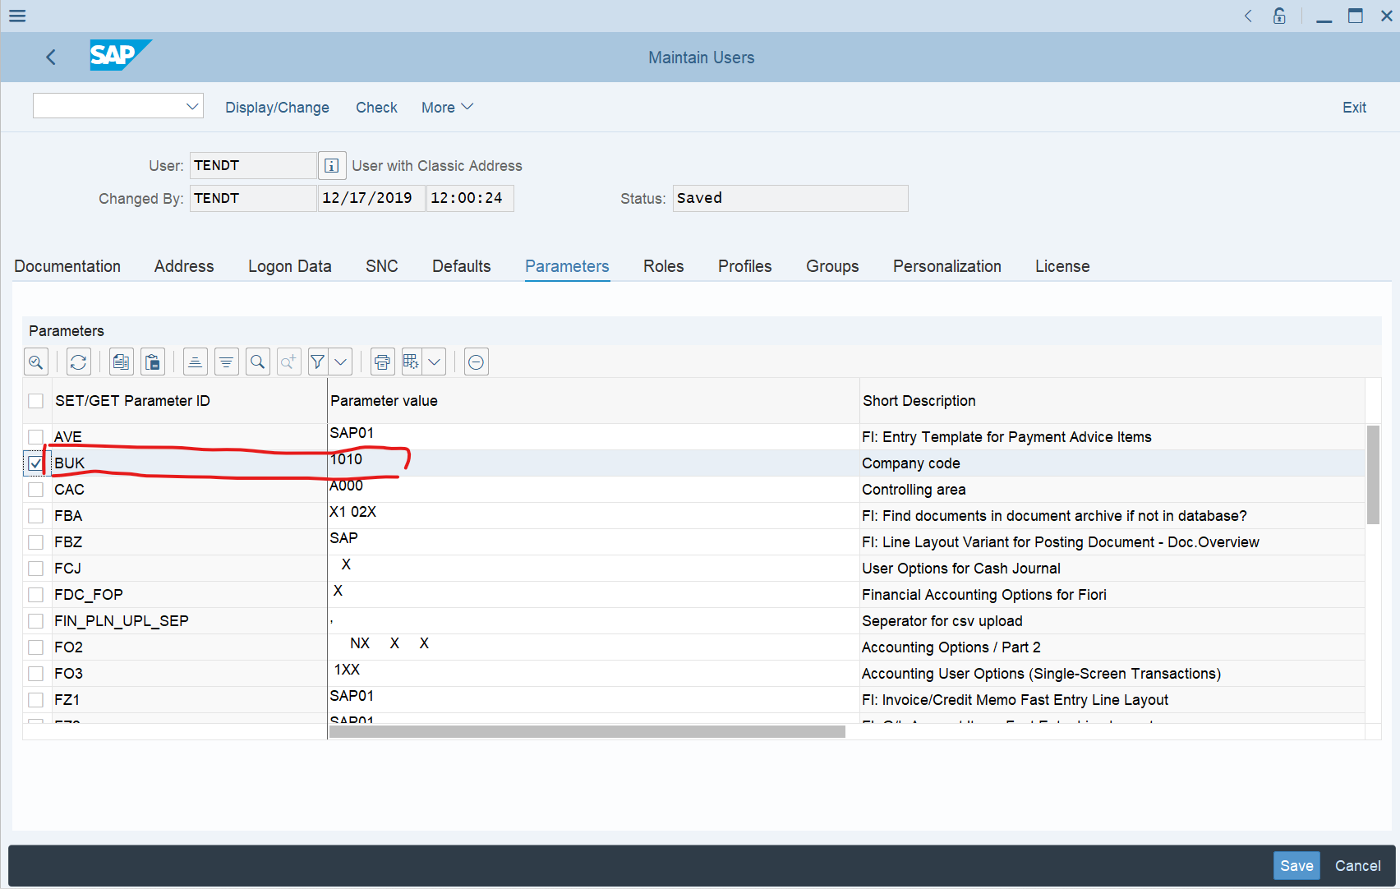

1. **Set your initial Password**

Select the tab “Logon data” and provide the initial Password. If you have a default Password for running the flow later in mind, do *not* enter now, as with the first Logon you need to change it again.

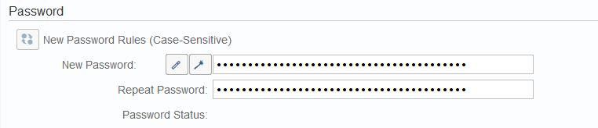

1. **Logoff from current and first Logon with your new User**

When you Logon the first time, you need to change your initial Password. The once logged on, you need to adjust one more thing

1. **First time with your new user logged on – Change F4 help**

Select on the main menu “More > Help > Settings” and then select:  
F1-HELP: “in modal dialog box”  
F4-HELP: “dialog modal”

